Name: ELA Do Nows Date: May 11 – 15, 2020
Monday | Tuesday | Wednesday | Thursday
Circle the words that need to be capitalized.  my birthday is in august.  Rewrite the sentence correctly.  __________________  ___________________  ___________________  ____________________ | Circle the words that need to be capitalized.  bill took the dog to sally’s house.  Rewrite the sentence correctly.  __________________  ___________________  ___________________  ____________________ | Circle the words that need to be capitalized.  his brother’s name is david.  Rewrite the sentence correctly.  __________________  ___________________  ___________________  ____________________ | Circle the words that need to be capitalized.  the girl will go to the library on friday.  Rewrite the sentence correctly.  __________________  ___________________  ___________________  ____________________
If the suffix – ful means “full of”  What does cheerful mean?  _____________________  _____________________  Write a sentence with it?  _____________________  _____________________ | If the suffix – ful means “full of”  What does careful mean?  _____________________  _____________________  Write a sentence with it?  _____________________  _____________________ | If the suffix – ful means “full of”  What does painful mean?  _____________________  _____________________  Write a sentence with it?  _____________________  _____________________  . | If the suffix – ful means “full of”  What does hopeful mean?  _____________________  _____________________  Write a sentence with it?  _____________________  _____________________
If the suffix – ly means “in a ______ way”, sadly would mean “ in a sad way”.  What would quietly mean?  _____________________  _____________________  Write a sentence with it?  _____________________  _____________________ | If the suffix – ly means “in a ______ way”, sadly would mean “ in a sad way”.  What would neatly mean?  _____________________  _____________________  Write a sentence with it?  _____________________  _____________________ | f the suffix – ly means “in a ______ way”, sadly would mean “ in a sad way”.  What would bravely mean?  _____________________  _____________________  Write a sentence with it?  _____________________  _____________________ | f the suffix – ly means “in a ______ way”, sadly would mean “ in a sad way”.  What would quickly mean?  _____________________  _____________________  Write a sentence with it?  _____________________  _____________________
Read your decodable  Studying Animals  and circle all the words with suffixes – ful, -ly, and -y and your high frequency words.  Then answer these questions.  1.Finish the sentence.  The lion will growl _________.  2. Which birds cannot fly?  ____________________  ____________________  3. What does a squid and octopus have?  ____________________  ____________________ | Read your decodable  Jack and the Beans  and circle all the words with suffixes – ful, -ly, and -y and your high frequency words.  Then answer these questions.  1.Finish the sentence.  Jack and Jill ate their last handful of __________.  2.What did Jack trade his fat cow for?  ____________________  ____________________  3. What were Jack and Jill thankful for?  ____________________  ____________________ | Read your decodable  Ruth’s Day  and circle all the words with suffixes – ful, -ly, and -y and your high frequency words.  Then answer these questions.  1.Finish the sentence.  Ruth ate her ________ Pops quickly.  2. What is another word for funny in this story?  ____________________  ____________________  3. How was Ruth a good friend to Edith?  ____________________  ____________________ | Read your decodable  Stew for Peg  and circle all the words with suffixes – ful, -ly, and -y and your high frequency words.  Then answer these questions.  1.Finish the sentence.  Jo wanted to make a ______ for Peg.  2.What did Toby put in the pot?  ____________________  ____________________  3. Did Peg like the treat?  ____________________  ____________________
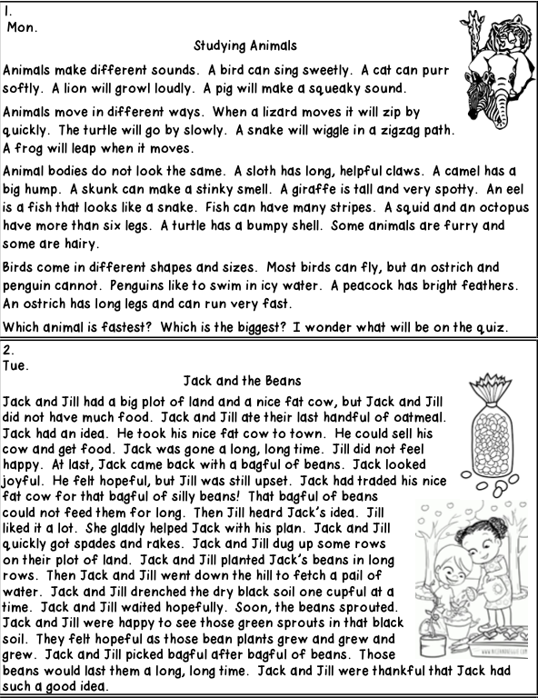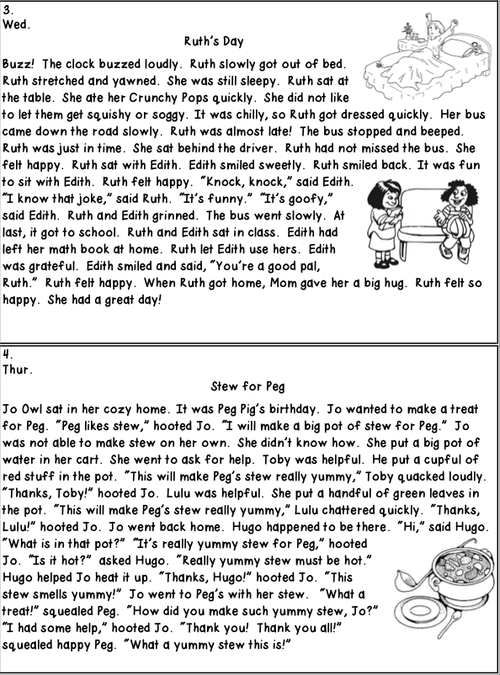
Name: Math Do Now Date: May 11 – 15, 2020
Monday | Tuesday | Wednesday | Thursday
How many tens and ones are there in the number 75?  ______ Tens  ______ Ones | Underline the digit in the tens place.  36 | How many tens and ones are there in the number 59?  ______ Tens  ______ Ones | Underline the digit in the ones place.  52
Complete each family of facts.  5 5 10  ____ + ____ = ____  ____ + ____ = ____  ____ - ____ = ____  ____ - ____ = ____ | Complete each family of facts.  2 8 6  ____ + ____ = ____  ____ + ____ = ____  ____ - ____ = ____  ____ - ____ = ____ | Complete each family of facts.  10 7 3  ____ + ____ = ____  ____ + ____ = ____  ____ - ____ = ____  ____ - ____ = ____ | Complete each family of facts.  4 3 7  ____ + ____ = ____  ____ + ____ = ____  ____ - ____ = ____  ____ - ____ = ____
What is…  14  One more? ______  One less? ______  Ten more? ______  Ten less? ______ | What is…  26  One more? ______  One less? ______  Ten more? ______  Ten less? ______ | What is…  55  One more? ______  One less? ______  Ten more? ______  Ten less? ______ | What is…  31  One more? ______  One less? ______  Ten more? ______  Ten less? ______
Find the missing number.  + 8 = 13 | Find the missing number.  12 + = 18 | Find the missing number.  7 + 8 = | Find the missing number.  + 9 = 20
Find the missing number.  14 - = 8 | Find the missing number.  - 5 = 11 | Find the missing number.  20 - = 16 | Find the missing number.  13 - 9 =
Circle the equation that is TRUE.  16 - 7 = 10  8 + 11 = 19 | Find the sum.  5 + 7 + 3 = | Circle the equation that is TRUE.  12 - 6 = 6  6 + 12 = 6 | Find the sum.  8 + 5 + 3 =
I need fourteen pencils to share with my class. I have 8 so far. How many more pencils do I need? | There are 12 markers in the box. I put 5 more in. How many markers are now in the box? | There are 15 students in line. Five of them go back to class. How many students are still in line? | I gave out eight red pencils, and seven green pencils. How many pencils did I give out in all?
3 4 2  ____ ones  ____ tens  ____ hundreds | Write the number.  0 ones  4 tens  5 hundreds | What is the value of the 4 in 475? | What is the value of the 3 in 630?

